ASSESSMENT TOOL 1- CO1

COURSE NAME: Artificial Intelligence COURSE CODE:CSA1715

Analytical Problem Solving

I S. Lakshita(192524108) certify that this submission is my original work and that I have adhered to the guidelines specified for this assessment. I understand that any violation of academic integrity rules will result in disciplinary action.

1. Solve the Water Jug problem: you are given 2 jugs, a 4-gallon one and 3-gallon one. Neither has any measuring maker on it. There is a pump that can be used to fill the jugs with water. How can you get exactly 2 gallons of water into 4-gallon jug? Explicit assumptions: A jug can be filled from the pump, water can be poured out of a jug onto the ground, water can be poured from one jug to another and that there are no other measuring devices available.
Answer:
Initial State:
(4-gallon, 3-gallon) = (0,0)
Step | Action | State (4G,3G)
1 | Fill 3-gallon jug | (0,3)
2 | Pour into 4-gallon jug | (3,0)
3 | Fill 3-gallon jug again | (3,3)
4 | Pour into 4-gallon until full | (4,2)
5 | Empty 4-gallon jug | (0,2)
6 | Pour remaining 2 gallons into 4-gallon jug | (2,0)
Goal State:
(2,0)
The goal state (2,0) is reached successfully. Therefore, exactly 2 gallons of water are obtained in the 4-gallon jug.
2.Find out how Mars Rover, analyse and explore the samples on Mars by answering the following questions.
- What are the percept’s for this agent?
- Characterize the operating environment.
- What are the actions the agent can take?
- How can one evaluate the performance of the agent?
- What sort of agent architecture do you think is most suitable for this agent? Why?

Answer:

Problem Understanding
A Mars Rover is an autonomous intelligent agent that explores the surface of Mars, collects scientific information, analyzes rocks and soil, and sends the collected data back to Earth. Since communication with Earth is delayed, the rover must make many decisions on its own.

i. Percepts
The rover gathers information from its sensors, including:
- Camera images
- Rock and soil composition
- Temperature
- Atmospheric pressure
- Terrain and obstacle information
- Battery level
- Wheel condition
- Position and orientation

ii. Characterization of the Operating Environment
The Mars Rover operates in an environment that is:
- Partially Observable – not all information is immediately available.
- Sequential – current actions influence future actions.
- Dynamic – weather and terrain conditions may change.
- Continuous – movement and sensing occur continuously.
- Single Agent – only the rover performs tasks.
- Uncertain – unexpected obstacles and environmental conditions may occur.

iii. Actions Performed by the Rover
- Move forward or backward.
- Turn left or right.
- Capture photographs.
- Drill rocks.
- Collect soil samples.
- Analyze samples.
- Transmit scientific data.
- Recharge battery using solar panels.
- Avoid obstacles.

iv. Performance Measure
The performance of the Mars Rover is evaluated by:
- Accuracy of navigation.
- Number of successful sample collections.
- Efficient energy utilization.
- Successful obstacle avoidance.
- Quality of scientific data collected.
- Reliable communication with Earth.
- Mission completion within available resources.

v. Suitable Agent Architecture
Utility-Based Learning Agent
Reason:
A Utility-Based Learning Agent is most suitable because it:
- Learns from previous experiences.
- Makes decisions that maximize scientific value.
- Adapts to changing environments.
- Operates efficiently under uncertainty.
- Selects actions that provide the highest overall benefit.

3.Explore the search space using search strategies and formulate the problem components for the 8-Queens problem using the following information: Place 8 queens on a chessboard such that none of the queen’s attack any of the others. A configuration of 8 queens on the board as shown in the figure below, but this does not represent a solution as the queen in the first column is on the same diagonal as the queen in the last column.

Answer:

The objective of the 8-Queens problem is to place eight queens on an 8 × 8 chessboard such that no queen attacks another. A queen can attack horizontally, vertically, and diagonally.
Problem Formulation
Initial State
An empty chessboard.
State Space
All possible arrangements of eight queens on the chessboard.
Operators
- Place a queen in a safe position.
- Move a queen to another row if conflicts occur.
Goal State
Eight queens are placed such that:
- No two queens are in the same row.
- No two queens are in the same column.
- No two queens are on the same diagonal.
Path Cost
Each queen placement has a cost of 1.
Search Strategy
The most suitable search strategy is Backtracking (Depth-First Search) because:
- It explores one possible solution at a time.
- It immediately discards invalid placements.
- It significantly reduces unnecessary search.

State Space Analysis
Without constraints:
$$8^{8}=16,777,216$$
possible arrangements exist.
Using Backtracking, only promising configurations are explored, reducing computation significantly.

Example Representation
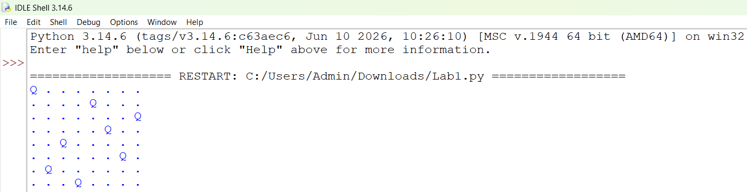

Advantages of Backtracking
- Efficient search.
- Eliminates invalid states early.
- Uses less memory than Breadth-First Search.
- Guarantees a valid solution if one exists.

The 8-Queens problem is a classical constraint satisfaction problem that is efficiently solved using Backtracking with Depth-First Search.

4. A customer wants to travel from the one location to another location using OLA Cab booking mobile application. The customer can select the any of the cab type as mini, micro, sedan, shared, prime and so on based on his comfort to reach the destination. Identify what type of problem-solving agent can be used and write the pseudocode for the above problem.

Answer:

An OLA customer wants to travel from one location to another. The application provides multiple cab options such as Mini, Micro, Sedan, Shared, and Prime. The system must select the most suitable cab according to the customer's preferences and complete the booking.

Suitable Problem-Solving Agent
Goal-Based Agent
Reason
A Goal-Based Agent chooses actions that help achieve a specific goal. Here, the goal is to transport the customer safely and efficiently to the destination while satisfying preferences such as comfort, travel time, and cost.

Working Process
- Customer enters source and destination.
- System identifies available cab types.
- Estimated fare and arrival time are calculated.
- Customer selects the preferred cab.
- The system checks availability.
- If available, booking is confirmed.
- Driver details and live location are displayed.
- The trip begins and ends at the destination.

Pseudocode

START

Input Source
Input Destination

Display available cabs
(Mini, Micro, Sedan, Shared, Prime)

User selects preferred cab

IF selected cab is available THEN
Calculate fare
Confirm booking
Assign driver
Display driver details
Start trip
ELSE
Display "Cab Not Available"
ENDIF

END

Performance Measure
- Correct cab selection.
- Minimum waiting time.
- Accurate fare estimation.
- Customer satisfaction.
- Successful trip completion.
- Safe transportation.

A Goal-Based Agent is the most appropriate because it evaluates available options and selects the one that best satisfies the customer's travel objective.

5.A logistics company operates a delivery network where packages must be transported between warehouses at minimum cost. Each route between warehouses has an associated travel cost (fuel + time). The company wants to determine the least-cost path from the starting warehouse S to the destination warehouse G using the Uniform Cost Search (UCS) algorithm.

The delivery network is represented as a weighted graph:

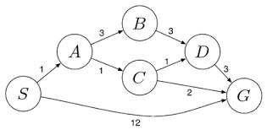
Answer:

A logistics company wants to transport packages from the starting warehouse S to the destination warehouse G with the minimum transportation cost. Each route has an associated travel cost. The objective is to determine the least-cost path using the Uniform Cost Search (UCS) algorithm.

Problem Formulation
- Initial State: S
- Goal State: G
- State Space: {S, A, B, C, D, G}
- Operators: Move from one warehouse to another through the available routes.
- Path Cost: Sum of the costs of all traversed routes.
- Search Strategy: Uniform Cost Search (UCS)

Available Routes
Route | Cost
S → A | 1
S → G | 12
A → B | 3
A → C | 1
B → D | 3
C → D | 1
C → G | 2
D → G | 3
UCS Search Process
Step | Expanded Node | Cumulative Cost
1 | S | 0
2 | A | 1
3 | C | 2
4 | D | 3
5 | B | 4
6 | G (Goal) | 4

Possible Paths
Path | Total Cost
S → G | 12
S → A → C → G | 4
S → A → C → D → G | 6
S → A → B → D → G | 10

Algorithm
- Start from node S with cost 0.
- Insert all neighboring nodes into the priority queue.
- Expand the node with the lowest cumulative cost.
- Continue expanding nodes until the goal node G is reached.
- Return the path with the minimum cost.

Result
- Least-Cost Path: S → A → C → G
- Minimum Cost: 4

Uniform Cost Search always expands the node with the lowest cumulative path cost, ensuring the optimal solution. For the given delivery network, the least-cost route is S → A → C → G with a minimum cost of 4.

